Hi XXXX,

Thanks for connecting back on LinkedIn, I did try to reach out on their messaging app but not sure how active you are on there.

I thought I would drop you a quick note as I am keen to setup a call to discuss the potential of becoming one of our ‘Construction Excellence Showcases’ for the next editions of Business Chief Asia and Construction Global.

We are running a series of feature articles called 'The Journey to Construction & Technology Transformation' and have been focusing on the following areas amongst others:  
﻿  
● Construction Transformations

● Digital Disruption Initiatives

● Vendor Management Strategies

● Construction 4.0 & Big Data

● AI / Machine Learning

I think you could potentially be a perfect fit to be featured in the March/April issue and I would welcome the opportunity to discuss further, below are the latest editions of the magazines as well as a couple of examples of our brochures that are custom built post magazine, just click the covers:

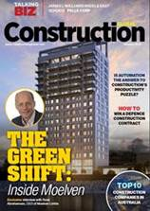 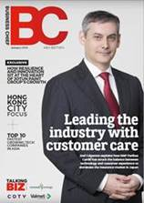  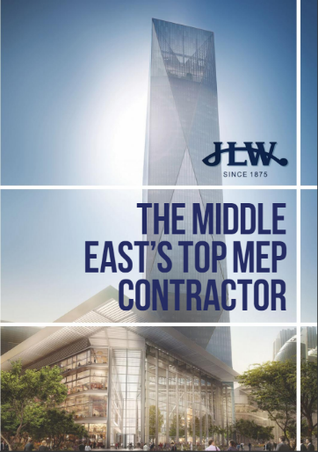 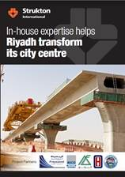 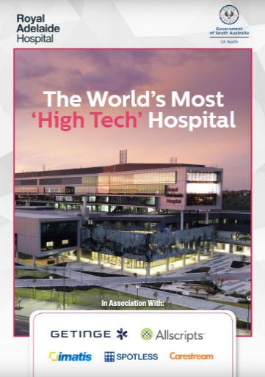

Let me know if this is of interest as I would like to try and set up a call in the next few days?

Thanks,